HPS winners:
Congratulations to the 2025 HPS Grant Winners!
Kingston Wai Chiu Mak Yeung is a PhD candidate at the University of Sydney, researching ways to improve transitions of care and medication safety. The HPS Research Grant will help support the “Evaluation of a Pharmacy Technician-Enhanced Transition of Care (PETOC) model to facilitate post-discharge Home Medicines Reviews for high-risk patients.
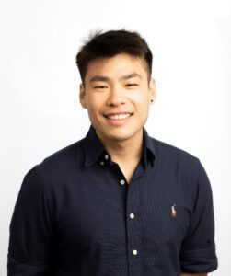 | “It is such an honour to be a recipient of the FIP HPS Research Grant 2025, and I would like to thank the FIP Hospital Pharmacy Section for their support. This funding will support a project evaluating a new model of care aimed at improving patient outcomes and reducing medication-related harms. This project represents an important step towards empowering pharmacy technicians to practice at the top of their scope, whilst also expanding the role of pharmacists in ensuring safer transitions of care.”

Katelyn Jauregui is from Australia and is a PhD candidate at the University of Sydney and a clinical pharmacist at Campbelltown Hospital. The HPS Research Grant will support her research exploring clinicians’ rationales for prescribing extended-release rather than immediate-release opioids for acute postoperative pain.
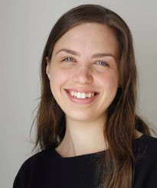 | “I am honoured and incredibly grateful to receive the FIP HPSResearch Grant for 2025. This support will enable us to explore why clinicians continue to prescribe extended-release opioids for acute pain following surgery, despite guideline recommendations to avoid their use. The findings will empower hospital pharmacists to lead improvement in opioid prescribing, reduce medication-related harm, and strengthen evidence-based practice globally. My sincere thanks to the FIP Foundation and the Hospital Pharmacy Section for supporting this exciting work.

2024:

“I am truly honoured and grateful to have been selected as the recipient of the FIP HPS Research Grant for 2024. I would like to extend my heartfelt thanks to the FIP Foundation for their generous support and for recognizing the value of my research proposal on “Prescribing appropriateness criteria for older Sri Lankan adults.” This funding will greatly assist in conducting essential fieldwork and analysis, and I believe it will contribute to improving healthcare outcomes for older adults. Once again, thank you for your trust and support in my work, and I look forward to achieving meaningful results through this project.”

Godakanda Arachchige Maneesha Prasadi a PhD candidate at The University of Sydney and a registered pharmacist, will conduct research on “Prescribing appropriateness criteria for older Sri Lankan adults.”


“I am deeply honored and grateful to receive the FIP Hospital Pharmacy Section Research Grant. This award is not just a recognition of our work but a crucial step toward elevating the role of pharmacists in multidisciplinary teams, especially in Latin America. With this support, we can drive the development of high-quality hospital pharmacy services, ensuring that pharmacists are integral in delivering comprehensive patient care. This grant will also empower us to build and establish practice standards that will set a new benchmark for excellence in our field, ultimately benefiting countless patients.”

Patricia Klahn Acuña is from Chile and won with the project: “Developing a pharmaceutical education approach for cancer patients on oral chemotherapy: overcoming barriers in resource-limited hospital settings.”
2023:


Moteehat Olubukola Olu-Lawal will conduct research on "Pharmaceutical care interventions: A tool for building interprofessional collaboration in two public healthcare institutions in Osun State."


Stephen Eckel will conduct research on "Comparison of the FIP Basel Statements on the future of hospital pharmacy practice and pharmacy school accreditation standards."

