Congratulations to the 2024 recipient:
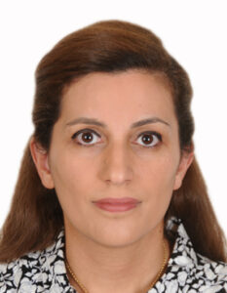
“This is a remarkable achievement to receive the FIP/BPS Award which is given to investigators and pharmacists to support research projects related to Board Certification. We are extremely interested in conducting the research project and looking forward to its great impact. The aim of this grant is to assess the impact of pharmacist board certification on specialisation and advanced practice through evaluating the influence on patient’s level, healthcare system, interprofessional collaboration, and pharmacist employment. The project is entitled” Evaluating Pharmacist Certification in the Middle East: Triangulated Perspectives and Experiences among Healthcare Providers, Pharmacists, and Pharmacy Students on pharmacist roles as interprofessional collaborator, communicator and educator”. We would like to thank the FIP/BPS for their recognition and support for the great initiative.”

Dr. Diana Malaeb earned her Bachelor of Pharmacy degree and her PharmD degree from the Lebanese American University (LAU). She also holds a Master degree in Clinical Pharmacy and Pharmacoepidemiology from the Lebanese University. She is also Board Certified in Pharmacotherapy. She earned her PhD in Clinical Research and Public health from Universite Paris Est Creteil in France. She had around 18 years of teaching experience in Pharmacy Schools where she held different administrative positions in addition to teaching and supervising students in their research. She is currently an Associate Professor and the College Research Coordinator at the College of Pharmacy at Gulf Medical University (GMU).

