HPS winners:
2024:
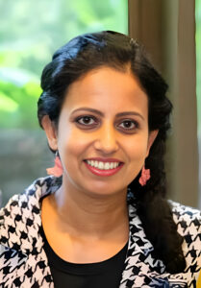
“I am truly honoured and grateful to have been selected as the recipient of the FIP HPS Research Grant for 2024. I would like to extend my heartfelt thanks to the FIP Foundation for their generous support and for recognizing the value of my research proposal on “Prescribing appropriateness criteria for older Sri Lankan adults.” This funding will greatly assist in conducting essential fieldwork and analysis, and I believe it will contribute to improving healthcare outcomes for older adults. Once again, thank you for your trust and support in my work, and I look forward to achieving meaningful results through this project.”

Godakanda Arachchige Maneesha Prasadi a PhD candidate at The University of Sydney and a registered pharmacist, will conduct research on “Prescribing appropriateness criteria for older Sri Lankan adults.”


“I am deeply honored and grateful to receive the FIP Hospital Pharmacy Section Research Grant. This award is not just a recognition of our work but a crucial step toward elevating the role of pharmacists in multidisciplinary teams, especially in Latin America. With this support, we can drive the development of high-quality hospital pharmacy services, ensuring that pharmacists are integral in delivering comprehensive patient care. This grant will also empower us to build and establish practice standards that will set a new benchmark for excellence in our field, ultimately benefiting countless patients.”

Patricia Klahn Acuña is from Chile and won with the project: “Developing a pharmaceutical education approach for cancer patients on oral chemotherapy: overcoming barriers in resource-limited hospital settings.”

2023:


Moteehat Olubukola Olu-Lawal will conduct research on "Pharmaceutical care interventions: A tool for building interprofessional collaboration in two public healthcare institutions in Osun State."


Stephen Eckel will conduct research on "Comparison of the FIP Basel Statements on the future of hospital pharmacy practice and pharmacy school accreditation standards."

