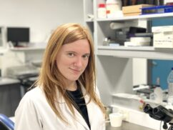
2024: Ana-Katharina Gehrke, Argentina
I would like to express my most sincere and deep gratitude for the financial support granted for the project “Lactococcus lactis carrying staphylococcal protein A as a new weapon to fight against Methicillin Resistant Staphylococcus aureus skin and soft tissue infections.” It is an honor to have been selected as the recipient of the FIP Foundation ECPG Innovation Frant 2024. This represents a unique opportunity to make a contribution to society in the biomedical field as well as to enrich my training as a pharmaceutical scientist.

Ms. Ana-Katharina Elsa Gehrke is from Argentina and won with the project: “Lactococcus lactis carrying staphylococcal protein A as a new weapon to fight against Methicillin-Resistant Staphylococcus aureus skin and soft tissue infections.”

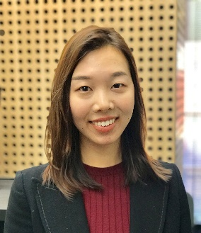
2023: Shania Liu, Australia
Shania Liu is a PHD candidate at the University of Sydney, Australia and Clinical Pharmacist at South Eastern Sydney Local Health District (SESLHD). Shania will conduct a project titled “Evaluation of a pharmacist-led opioid tapering service before orthopaedic surgery.” Results will be reported at the 2024 FIP World Congress in September 2024.

2022: Brian Cicali, USA
Brian Cicali is a Research Assistant Professor, at the Center for Pharmacometrics and Systems Pharmacology, Univ. of Florida. Brian’s project was titled “Model-informed Evidence Approach for Pediatric and Neonate Dosing of Tramadol.”

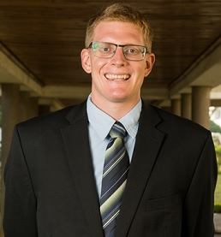
2020: Dallas Smith, Malawi
Dallas Smith is a recent PharmD graduate with a passion for equitable pharmaceutical interventions. He is a clinical pharmacy and pharmacognosy lecturer at the College of Medicine, University of Malawi. His project explores the role of an ambulatory care pharmacist in an outpatient hypertension clinic in urban Malawi. Through capacity building in this local pharmacist, this study will evaluate blood pressure control and medication adherence through medication therapy management (MTM) services. Dallas hopes the outcomes of this data will encourage public and private entities in Malawi to employ ambulatory pharmacists and expand the role of the pharmacy profession.

2019: Shepard Nqobile Mhlaba, Zimbabwe
Shepard Mhlaba is a Young Pharmacist from Zimbabwe, with keen interest in Global Health. He has served the International Pharmaceutical Federation Young Pharmacists Group as a Subcommittee Member and is currently serving FIP as Global Lead for Pharmaceutical Workforce Development Hub. His research on integrating supply chain management practices in community pharmacies and information technology was inspired by the disheartening poor supply chain practices affecting developing countries. This has resulted in significant expired medicines. His research aims to improve access to medicines and also to give a step towards universal health coverage by ensuring effective use of available scarce resources.

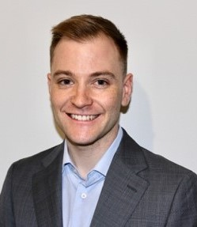
2018: Jack Collins, Australia
Jack is a PhD candidate at The University of Sydney and a practising community pharmacist in Australia. Jack’s area of research is the role of the community pharmacy in consumer self-care. His project explores whether implicit (unconscious) racial bias is present in practising community pharmacists through the use of simulated patients. Through this pilot research, Jack aims to determine to what extent implicit racial bias is present and then use these findings to go on to explore other potential biases and eventually develop interventions to address this bias to improve the uniformity of patient care regardless of patient demography.
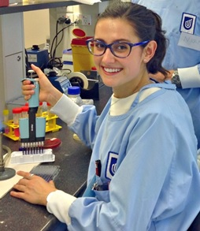
2017: Chelsea Thorn, Australia
Chelsea is a PhD candidate from the University of South Australia and a registered pharmacist in Australia. Her project focuses on identifying new solutions to treat highly tolerant bacterial infections relating to biofilms. The direction is to deliver antibiotics with biofilm-dispersing enzymes through a nano-carrier delivery formulation.
With the innovative formulation, Chelsea is attempting to improve the efficacy of infection treatment, especially for the drug-tolerant infections.

2016: Ekpenyong Aniekan, Nigeria
Ekpenyong’s project was about developing adequate human resources for
pharmacy in developing countries. It was piloted in Nigeria and involved using
data to make a five-year trend assessment and in-depth analysis of the pharmacy workforceacross 36 states to inform workforce planning and policy development.

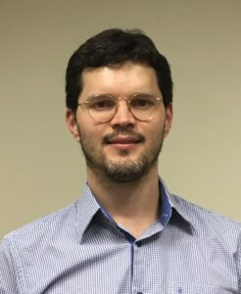
2015 Arcelio Benetoli, Australia
Arcelio was a PhD candidate in Pharmacy Practice at the University of Sydney, and before that received his MSc in Pharmaceutical Sciences from the State University of Maringa, Brazil. His research focused on how consumers use social media for health purposes. The research comprised an observational study which identified chronic disease public Facebook groups whose content was quantitatively and qualitatively analysed and consumer focus groups. Understanding how consumers use social media will assist health care providers in guiding consumers in their social media health journey; and importantly, help design innovative ways to deliver care via social media, accessing people who may not visit health care professionals regularly.

2014 Vivian Tong, Australia
Vivian was a PhD Candidate at the University of Sydney. Her PhD focus was on optimising written medicine information to support safe and appropriate consumer use of over-the-counter medicines. The research focus for the grant was to develop and test alternative standardised over-the-counter medicine label formats. The new labels were informed by consumer opinions and good information design. Vivian found that the new labels performed well when user tested and consumers were able to find and understand key points of information about their medicine.

